MEHRAN UNIVERSITY

OF ENGINEERING & TECHNOLOGY

JAMSHORO, PAKISTAN

Design the network and apply the knowledge of routing protocol to configure the EIGRP protocol in network

Subject: COMPUTER NETWORKS (PR)

(Lab 12 - Tasks Solution)

|  |  |
| --- | --- |
| **Roll No:** | **22SW028** |
| **Section:** | **I** |

**NETWORK CONFIGURATION**

**USING EIGRP**

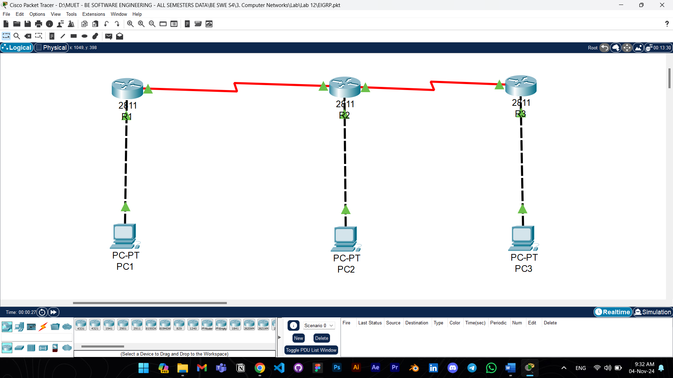

Answers to the questions given in Lab Manuals are below.

**Answers to Questions:**

**Q1: Can an interface configured with an IP address be in a down state?**

Ans: Yes, an interface can be in a down state if it's administratively shut down or if there’s a connectivity issue

**Q2: What are the major network entries in the ROUTER2 routing table?**

Ans

R2:

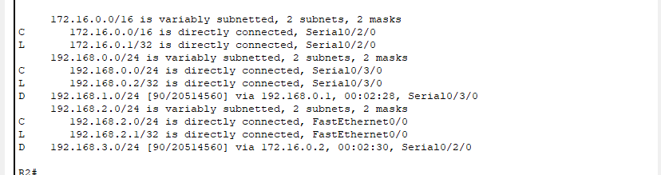

**Q3: What is meant by eigrp 20?**

Ans: eigrp 20 designates an EIGRP routing process with Autonomous System (AS) number 20. Routers in the same AS can exchange EIGRP information. We can use any number instead of 20.A white screen with black text

**Q4: What is meant by [90/1628160]?**

Ans: 90 is the administrative distance of EIGRP (indicating trustworthiness), and 1628160 is the composite metric calculated by EIGRP for the route, indicating the cost.

**Q5: List the summary route for networks 192.168.0.0/26, 192.168.1.0/29, and 192.168.2.0/30**

Ans: The summary route for these networks would be **192.168.0.0/22.** This consolidates the networks into a single route summarizing 192.168.0.0 to 192.168.3.255.

**Checking Connectivity:**

PC1 to PC2:

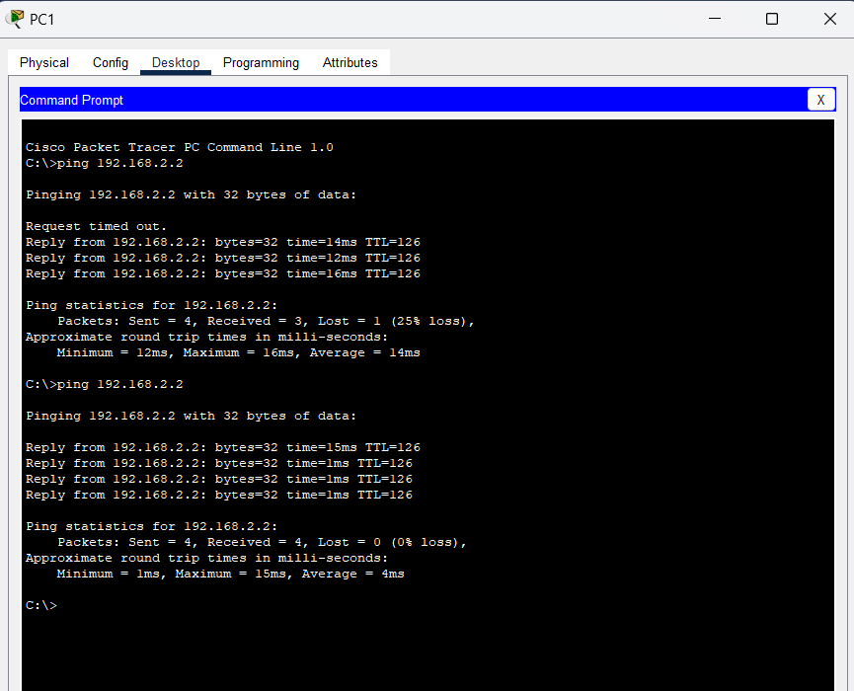

PC1 to PC3:

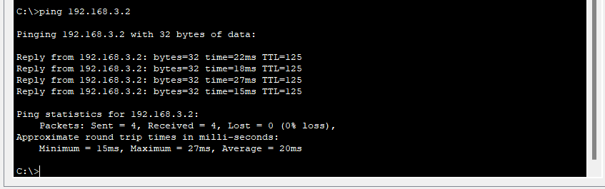

Note: The configuration commands aren’t added in the tasks as they are already present in the manual. The packet tracer file of the following task is also attached with the assignment.